**[OPINION](https://www.bostonherald.com/opinion/)**

**Chieppo: Newton teachers strike not ‘for the children’**

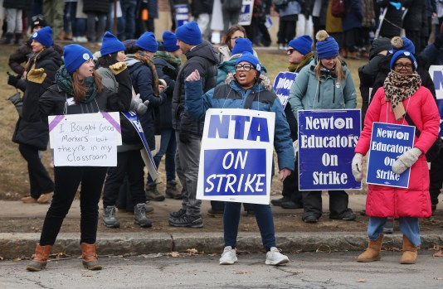

Striking Newton teachers rally at the Education Center. (Nancy Lane/Boston Herald)



By [**CHARLES CHIEPPO**](https://www.bostonherald.com/author/charles-chieppo/)

UPDATED: February 1, 2024 at 10:25 p.m.

If you like excess, one-party states are the places for you.  Whether you prefer Marjorie Taylor Greene’s calls for red states to secede or the Squad’s class warfare slogans, they’ve got it covered.

Of late, the Massachusetts version of one-party excess is playing out in a series of illegal teacher strikes, the most recent in Newton.  If, as union leaders assure us, the strikes are “for the children,” their timing sure is curious.

The educational damage done to Massachusetts students during the COVID-19 pandemic was immeasurable, and some of it is likely irreversible to the young people who just experienced it.  The commonwealth was among the hardest-hit states.  According to Dr. Eric Hanushek at Stanford’s Hoover Institution, the pandemic will reduce the lifetime earnings of Bay State students by more than 7% and diminish the Commonwealth’s gross domestic product by over 2.5%.

In addition to learning loss, the teacher strikes come as students are dealing with lingering mental health impacts from the pandemic, as demonstrated by increased student absenteeism.

As if sent directly from central casting, enter Massachusetts Teachers Association (MTA) President Max Page, who weaves a narrative of powerless educators desperately trying to get the attention of fat-cat school committees.  It’s an appealing pitch, if a little short on truth.

The MTA is, of course, the most powerful force on Beacon Hill.  They often elect the school committees who appoint the superintendents who together negotiate the teacher contracts.

When supporters raised $23 million for a successful campaign to amend the state Constitution and raise taxes in 2022, $15.5 million of it came from that ragtag band of underdogs, the MTA.

Page first tried out his David vs. Goliath pitch on the state Board of Elementary and Secondary Education, informing them that their “focus on income, on college and career readiness, speaks to a system . . . tied to the capitalist class and its needs for profit.”

After hearing the remarks, Paul Harrington, an economist who spent years at Northeastern University’s Center for Labor Market Studies, told CommonWealth magazine that Page’s comments sounded “like 1850 Karl Marx.”

There is one slice of encouraging news.  Governor Maura Healey, House Speaker Ron Mariano, and Senate President Karen Spilka have all come out against MTA-backed legislation to legalize teacher strikes.

Massachusetts’ excesses, as most recently symbolized by Max Page and the MTA, may be unique, but they’re no worse than what happens in other states where the right or left has an iron grip on politics.  When one party accumulates too much power in a democracy, it’s just a matter of time before reality starts looking like the image in a fun house mirror.

*Charles Chieppo is a senior fellow at Pioneer Institute, a Boston-based public policy think tank.*